
TN-IMPACT 2026
IDENTIFYING INDUSTRIAL CHALLENGES

PROBLEM STATEMENT NUMBER - TNI26178
PROBLEM STATEMENT TITLE - Innovation in Integrating Smart Sensors for Real-Time Valve Condition Monitoring: Description[Text Wrapping Break]Installed valves often fail without early signs; maintenance is reactive. Lack of condition data leads to unplanned shutdowns, safety risks, and high maintenance costs

Submitted by
ABISHEK KUMARAN M (711124106002)
JANANI S (711124106037)

Certificate
This report is submitted by TEAM JIT , consisting of students pursuing B.E in ELECTRONCICS AND COMMUNICATION ENGINEERING , II, 4th Semester, from JANSONS INSTITUTE OF TECHNOLOGY, under the guidance of MRS S SUSIKALA as part of the TN-IMPACT 2026 Hackathon.


SIGNATURE SIGNATURE SIGNATURE
(MRS S.SUSIKALA) (ABISHEK KUMARAN M ) (JANANI S)

ACKNOWLEDGEMENT
We would like to express our sincere gratitude to all the individuals and organizations who supported us in the successful completion of this project titled “Innovation in Integrating Smart Sensors for Real-Time Valve Condition Monitoring.”
First and foremost, we would like to thank our project guide and faculty members for their valuable guidance, encouragement, and technical support throughout the development of this project. Their insights and suggestions greatly helped us in understanding industrial monitoring systems and IIoT-based predictive maintenance technologies.
We are also grateful to the organizers and industry mentors of the TNI26178 Innovation Program for providing us with the opportunity to work on an industry-relevant problem related to valve assembly and quality control. Their feedback helped us refine our approach and understand real industrial requirements for smart monitoring systems.
We would also like to thank our institution for providing the necessary resources, technical infrastructure, and learning environment that enabled us to successfully design and implement the prototype monitoring dashboard and analytics system.
Finally, we extend our sincere thanks to all our friends, classmates, and well-wishers who supported us during the development and testing phases of this project.
This project has provided us with valuable knowledge in Industrial IoT, sensor integration, predictive maintenance analytics, and smart factory monitoring systems, which will greatly benefit our future work in industrial automation and intelligent monitoring solutions

TABLE OF CONTENTS

S.NO | TITLE | PAGE NUMBER
1 | ABSTRACT | 6
2 | INTRODUCTION | 7
3 | LITERATURE REVIEW | 7
4 | PROBLEM STATEMENT-Design methodol;ogy | 8
5 | Development of SYSTEM / prototype/ | 9
6 | Design validation/ Prototype testing | 10
7 | RESULTS AND DISCUSSIONS | 11
8 | CONCLUSION | 12

NOTE : Students are permitted to add relevant titles or sub-sections as needed to clearly present the report details.

LIST OF TABLES
S.NO | DESCRIPTION | PAGE NUMBER
1 | Hardware Components Specification | 13
2 | Software System Architecture | 14
3 | Sensor Parameter Measurement Table | 14
4 | Valve Health Prediction Parameter | 15
5 | Maintenance Log Data Structure | 16

LIST OF FIGURES
S.NO | DESCRIPTION | PAGE NUMBER
1 | Industrial System Architecture Diagram | 17
2 | Smart Valve Sensor Integration Block Diagram | 18
3 | Industrial Monitoring Dashboard Interface | 18
4 | Valve Risk Heatmap Visualization | 19
5 | Predictive Maintenance Workflow | 19

1. ABSTRACT
Industrial process plants depend heavily on valves for regulating flow, pressure, and safety within pipelines. Unexpected valve failures can lead to production downtime, safety hazards, and increased maintenance costs. In many industries, valve maintenance is still reactive, meaning faults are detected only after performance degradation or failure occurs.
This project proposes an Industrial Internet of Things (IIoT) based Smart Valve Condition Monitoring System that integrates multiple industrial sensors to continuously monitor valve operating parameters in real time. The system collects critical parameters including pressure, temperature, vibration, and valve position, which are essential indicators of valve health and operational stability.
The collected sensor data is transmitted to an Industrial Edge Gateway, where it is digitized and forwarded to a centralized monitoring platform. The platform provides a web-based industrial dashboard that visualizes real-time sensor readings, historical trends, system health indicators, and predictive maintenance alerts. Advanced analytics algorithms are applied to detect abnormal conditions and estimate the remaining useful life of the valve components.
The proposed system architecture is designed to be compatible with industrial PLC-based automation systems, SCADA platforms, and IIoT infrastructure, enabling seamless integration with existing industrial environments. For prototype validation, a simulated sensor environment was developed to emulate real industrial conditions while maintaining compatibility with real industrial sensors and communication standards.
The developed prototype demonstrates how smart sensor integration, predictive analytics, and real-time monitoring dashboards can significantly improve valve reliability, reduce unplanned shutdowns, and support data-driven maintenance strategies. This approach contributes to the transition toward Industry 4.0 and Industry 5.0 smart manufacturing systems by enabling intelligent, connected, and human-centered industrial operations.

2. INTRODUCTION
Modern industries such as oil and gas, chemical processing, power generation, and water treatment rely extensively on valves to control fluid flow within pipelines and processing units. The proper functioning of these valves is critical for maintaining process stability, operational safety, and production efficiency.
Traditional valve maintenance strategies are largely reactive or time-based, meaning that maintenance activities are scheduled at fixed intervals or performed after a failure occurs. This approach often results in unnecessary maintenance costs or unexpected equipment failures that lead to production downtime.
With the advancement of Industry 4.0 technologies, industries are increasingly adopting Industrial Internet of Things (IIoT) solutions that enable real-time monitoring and intelligent decision-making. Smart sensors, edge computing systems, and cloud-based analytics platforms allow industrial assets to continuously report their operational condition.
The concept of Industry 5.0 further expands this approach by focusing on human-centric intelligent systems, where advanced analytics assist operators in making informed maintenance decisions while improving operational safety and sustainability.
In this project, a Smart Valve Monitoring System has been developed that integrates industrial sensors with an IIoT monitoring platform. The system enables real-time visualization of valve parameters, automated fault detection, predictive maintenance alerts, and historical performance analysis.
The proposed architecture is designed to support industrial communication protocols, edge gateway integration, and scalable monitoring platforms, making it suitable for deployment in real industrial environments.

3. LITERATURE REVIEW
Several studies have highlighted the importance of predictive maintenance and condition monitoring in industrial systems.
Research in predictive maintenance technologies has shown that continuous monitoring of equipment parameters can significantly reduce downtime and maintenance costs. Sensors measuring vibration, temperature, and pressure are commonly used to detect early signs of equipment degradation.
Industrial monitoring systems based on Industrial Internet of Things (IIoT) platforms have been widely adopted to enable remote monitoring and data-driven decision-making. These systems collect real-time operational data from industrial assets and transmit the information to centralized monitoring platforms for analysis and visualization.
Recent advancements in edge computing allow industrial data to be processed closer to the equipment source, reducing latency and enabling faster response to abnormal conditions.
Machine learning algorithms have also been introduced in predictive maintenance systems to analyze equipment behavior patterns and estimate the remaining useful life (RUL) of components.
However, many existing solutions require expensive infrastructure or complex integration with industrial automation systems. Therefore, there is a need for cost-effective, scalable monitoring solutions that can be easily integrated into existing industrial valve assemblies.
The proposed system addresses this need by combining smart sensor integration, industrial gateway communication, and a web-based monitoring dashboard that can support both prototype validation and real industrial deployment.

4. PROBLEM STATEMENT
Industrial valves often operate in harsh environments where continuous mechanical stress, pressure variations, and thermal conditions can gradually degrade valve components. In many industrial facilities, valve failures occur without early warning signs due to the lack of continuous monitoring systems.
Key challenges include:
• Lack of real-time valve condition monitoring
• Reactive maintenance strategies leading to unexpected failures
• Limited visibility into valve operational parameters
• High maintenance costs and production downtime
• Safety risks caused by undetected valve malfunctions
To address these challenges, industries require a smart monitoring system capable of continuously analyzing valve performance parameters and providing early fault detection.
The objective of this project is to develop a Smart Valve Condition Monitoring System that integrates industrial sensors, real-time data acquisition, and predictive analytics to improve valve reliability and maintenance efficiency.

5. DEVELOPMENT OF SYSTEM / PROTOTYPE
The developed system consists of three major layers:
1. Sensor Layer
Industrial-grade sensors are integrated with the valve assembly to measure critical operational parameters.
Sensors include:
• Pressure sensor (pipeline pressure monitoring)
• Temperature sensor (process temperature monitoring)
• Vibration sensor (mechanical condition monitoring)
• Valve position sensor (open/close position detection)
These sensors continuously measure the operating conditions of the valve.
2. Edge Gateway Layer
Sensor signals are transmitted to an Industrial Edge Gateway, which performs the following functions:
• Signal conditioning and filtering
• Analog-to-digital signal conversion
• Data aggregation from multiple sensors
• Secure data transmission to the monitoring platform
The gateway acts as the interface between field devices and the monitoring system.

3. Monitoring Platform Layer
A web-based industrial dashboard was developed to visualize and analyze the collected sensor data.
The dashboard provides:
• Real-time valve parameter visualization
• Predictive maintenance alerts
• Valve health score analysis
• Historical trend monitoring
• Maintenance logs and operational status indicators
This interface enables plant operators and maintenance engineers to monitor valve performance and take corrective actions before failures occur.

6. DESIGN VALIDATION / PROTOTYPE TESTING
To validate the system design, a prototype implementation was developed that simulates industrial valve operating conditions.
The prototype was designed to demonstrate:
• Real-time sensor data acquisition
• Industrial gateway communication
• Dashboard-based monitoring interface
• Predictive maintenance analytics
Although simulated sensor inputs were used for prototype validation, the system architecture is fully compatible with real industrial sensors and industrial communication standards such as:
• 4–20 mA sensor signals
• Modbus communication
• Industrial Ethernet networks
• PLC-based control systems
This ensures that the developed system can be easily adapted for real industrial deployment.

7. RESULTS AND DISCUSSION
The developed monitoring system successfully demonstrates the integration of smart sensors, edge gateway communication, and an industrial monitoring dashboard.
The system was able to continuously monitor valve parameters including:
• Pressure
• Temperature
• Vibration
• Valve position
The dashboard provided real-time visualization of sensor data and generated predictive maintenance alerts when abnormal conditions were detected.
The predictive analytics module estimated valve health conditions and supported early detection of potential faults.
Compared with traditional maintenance methods, the proposed system offers several advantages:
• Continuous real-time monitoring
• Early detection of abnormal conditions
• Reduced maintenance costs
• Improved operational safety
• Data-driven maintenance planning
The prototype results confirm that the proposed architecture is suitable for integration into real industrial monitoring environments.

8. CONCLUSION
This project presented the development of a Smart Valve Condition Monitoring System based on Industrial Internet of Things (IIoT) technologies.
The system integrates industrial sensors, an edge gateway communication layer, and a web-based monitoring dashboard to provide continuous monitoring of valve operating conditions.
The proposed solution enables industries to transition from reactive maintenance strategies to predictive maintenance approaches, reducing equipment downtime and improving operational efficiency.
Although the prototype implementation uses simulated sensor data for validation, the system architecture is fully compatible with real industrial sensors and automation systems. This ensures that the developed solution can be deployed in real industrial environments with minimal modification.
The project demonstrates how smart sensor integration and intelligent monitoring platforms can support the development of Industry 4.0 and Industry 5.0 smart manufacturing systems.
Future work may include integrating machine learning models for advanced failure prediction, implementing industrial communication protocols such as OPC-UA, and deploying the system in a real industrial pilot environment.

Table 1: Hardware Components Specification
S.NO | Hardware Component | Description | Industrial Purpose
1 | Pressure Sensor | Industrial pressure transmitter (4–20 mA output) used to measure pipeline pressure | Detect abnormal pressure conditions and pipeline stress
2 | Temperature Sensor | PT100 RTD temperature sensor used for measuring valve body and fluid temperature | Monitor thermal conditions affecting valve operation
3 | Vibration Sensor | Industrial MEMS accelerometer sensor | Detect mechanical wear, cavitation, or structural vibration
4 | Valve Position Sensor | Rotary encoder / limit switch | Detect valve opening or closing position
5 | Signal Conditioning Module | Converts analog signals to stable measurable outputs | Ensures accurate sensor data acquisition
6 | Industrial Edge Gateway | Data acquisition and communication device | Collects sensor data and transmits to monitoring platform
7 | Industrial Power Supply | Regulated power source for sensors and gateway | Provides stable power to field devices
8 | Industrial Communication Interface | Ethernet / Modbus communication interface | Transfers data to monitoring dashboard

Table 2: Software System Architecture
This table describes the software architecture used in the monitoring system. The system is designed to collect sensor data, process the information, and present real-time monitoring through a web-based dashboard.
S.NO | Software Component | Description
1 | Data Acquisition Module | Collects sensor readings from the edge gateway
2 | Data Processing Module | Filters and processes incoming sensor signals
3 | Predictive Analytics Engine | Calculates valve health score and detects anomalies
4 | Database System | Stores historical sensor data and maintenance logs
5 | Web Dashboard Interface | Displays real-time valve parameters and system status
6 | Alert Management System | Generates alerts when abnormal conditions are detected
7 | User Authentication Module | Secures system access through login authentication

Table 3: Sensor Parameter Measurement Table
This table shows the key valve operating parameters monitored by the system along with their typical industrial measurement ranges.
S.NO | Parameter | Sensor Type | Measurement Range | Purpose
1 | Pressure | Pressure Transmitter | 0 – 100 bar | Monitor pipeline pressure levels
2 | Temperature | PT100 RTD Sensor | -50°C to 200°C | Monitor thermal conditions
3 | Vibration | MEMS Accelerometer | 0 – 20 mm/s RMS | Detect mechanical vibration and wear
4 | Valve Position | Rotary Encoder | 0 – 100 % | Detect valve opening position
5 | Flow (optional) | Flow Sensor | 0 – 500 L/min | Monitor fluid flow through valve

Table 4: Valve Health Prediction Parameters
This table defines the parameters used to evaluate the overall health condition of the valve.
S.NO | Parameter | Threshold Range | Health Impact
1 | Pressure | Above normal range | May indicate blockage or leakage
2 | Temperature | Excessive heat levels | Indicates thermal stress
3 | Vibration | High vibration amplitude | Indicates mechanical wear
4 | Valve Position Deviation | Incorrect position response | Indicates actuator malfunction
5 | Combined Health Score | Calculated from sensor data | Predicts valve condition
The predictive model analyzes these parameters and calculates a valve health score that helps identify early signs of failure.
Table 5: Maintenance Log Data Structure
This table describes the structure used to record valve maintenance activities in the monitoring dashboard.
S.NO | Field Name | Description
1 | Work Order ID | Unique identifier for maintenance record
2 | Valve ID | Identifies the monitored valve
3 | Maintenance Date | Date when maintenance was performed
4 | Technician Name | Responsible technician
5 | Maintenance Type | Inspection, calibration, repair, or replacement
6 | Description | Details of maintenance activity
7 | Status | Completed or pending maintenance
8 | Next Maintenance Date | Scheduled future maintenance
The maintenance log helps track valve service history and supports predictive maintenance planning.

Figure 1: Industrial System Architecture Diagram
A high-level architecture of the entire monitoring system.

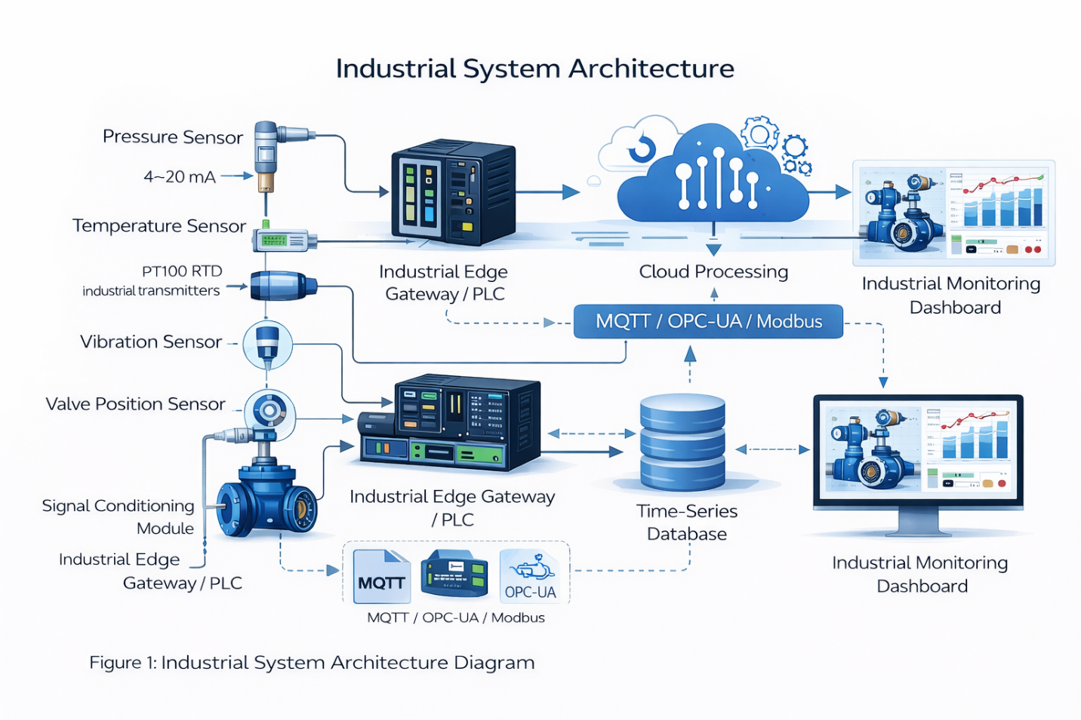
Shows the overall system architecture and data flow from valve sensors to the dashboard.

Figure 2: Smart Valve Sensor Integration Block Diagram
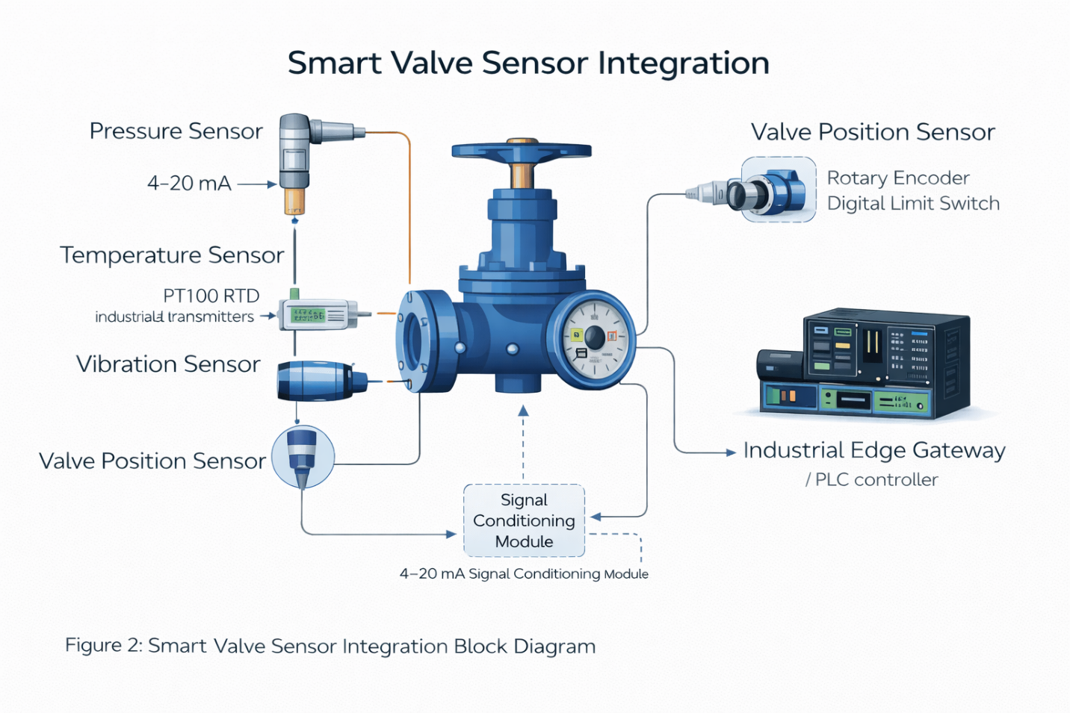
Figure 3: Industrial Monitoring Dashboard Interface
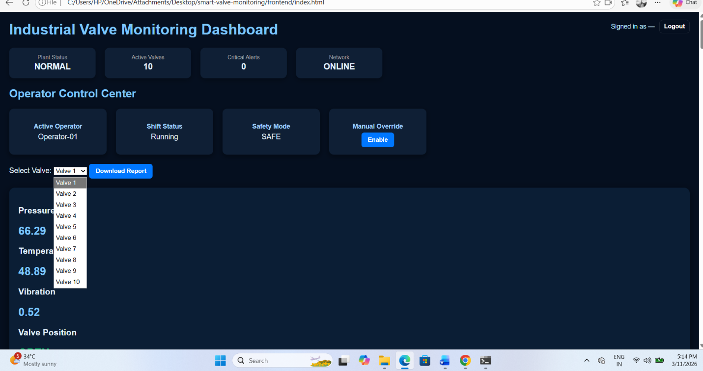
Figure 4: Valve Risk Heatmap Visualization
What the figure should show
A heatmap displaying valve risk levels.
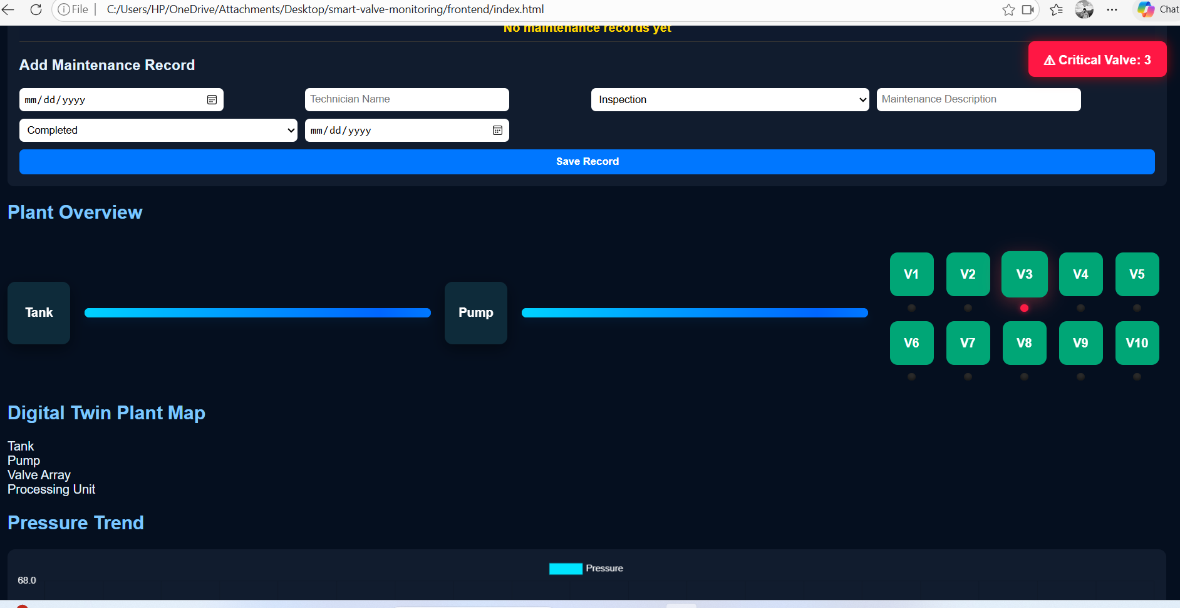

Figure 5: Predictive Maintenance Workflow
